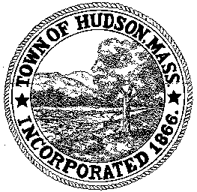

BOARD OF HEALTH
78 Main Street
Hudson, MA 01749
(978) 562-2020
Meeting Agenda
October 9, 2012
7:00 PM

- Preliminaries
1.1 Open Meeting
1.2 Roll Call

2.0 Application to Install Subsurface Sewage Disposal System
2.1 2 West Avenue
2.2 3 Crestview Drive
2.3 24 Murphy Road

3.0 General Business
3.1 Minutes – August 28, 2012
3.2 Voucher – BOH090412 $415
3.3 Request for Review and Comments – Cabot Ridge Apartments
3.4 Remote Participation during open meetings
3.5 Housing Update – Cipriano Pinto
3.6 Flu Clinic Update
3.7 Hazardous Waste Day update

4.0 Adjournment

Next Meeting: October 30, 2012

